Outgoing Mail Server Settings

- To Change Mail server setting, first find web.config file in your source code.

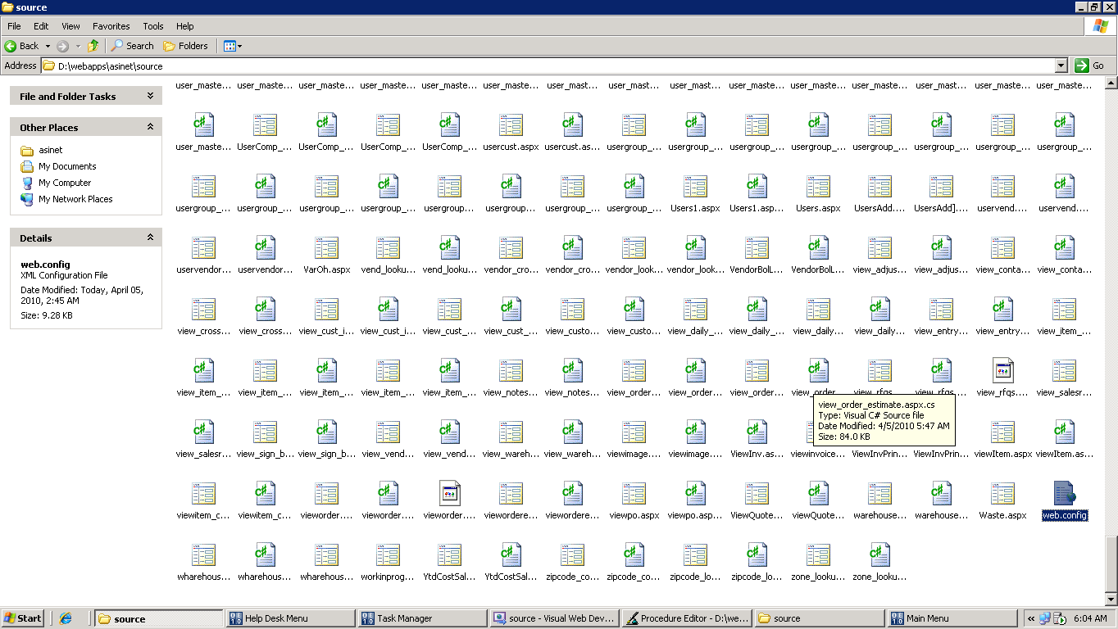

Web.config

- Open web.config file in any text editor & Find the portion of <system.net><mailSettings><smtp> ----------------------------------</smtp></mailSettings></system.net> to change your hostname, username or password. As the screen displayed below:

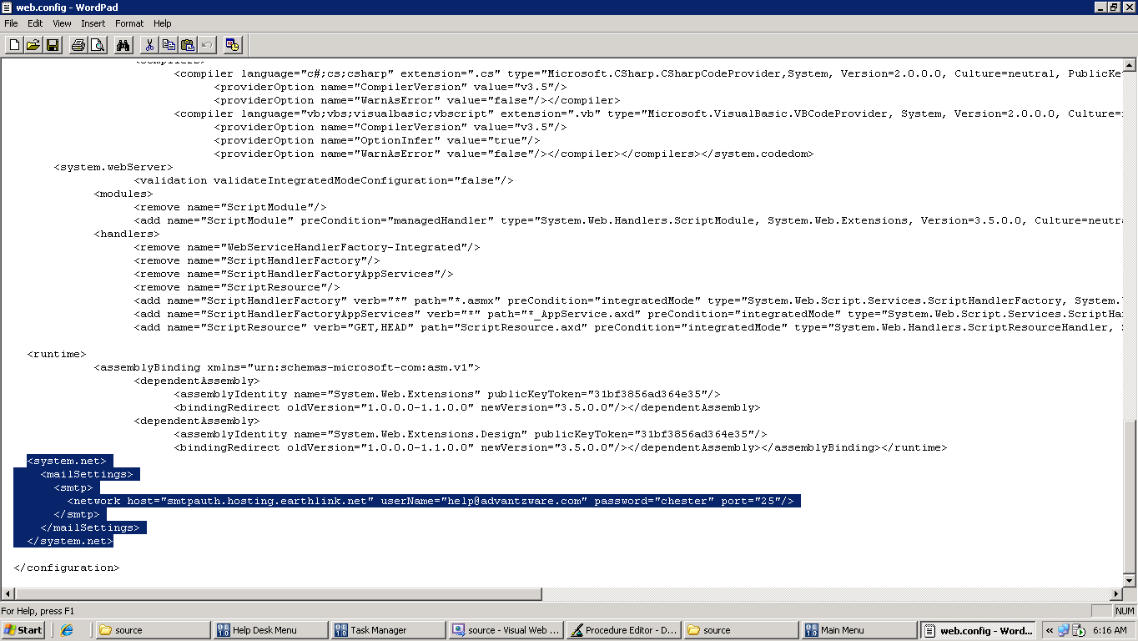
Change Host Name
Change User Name
Change Password

